1. Source---Three Excel files Emp1, emp2, empl3  
   Destination--SQL Table-Employee table

Data Flow :

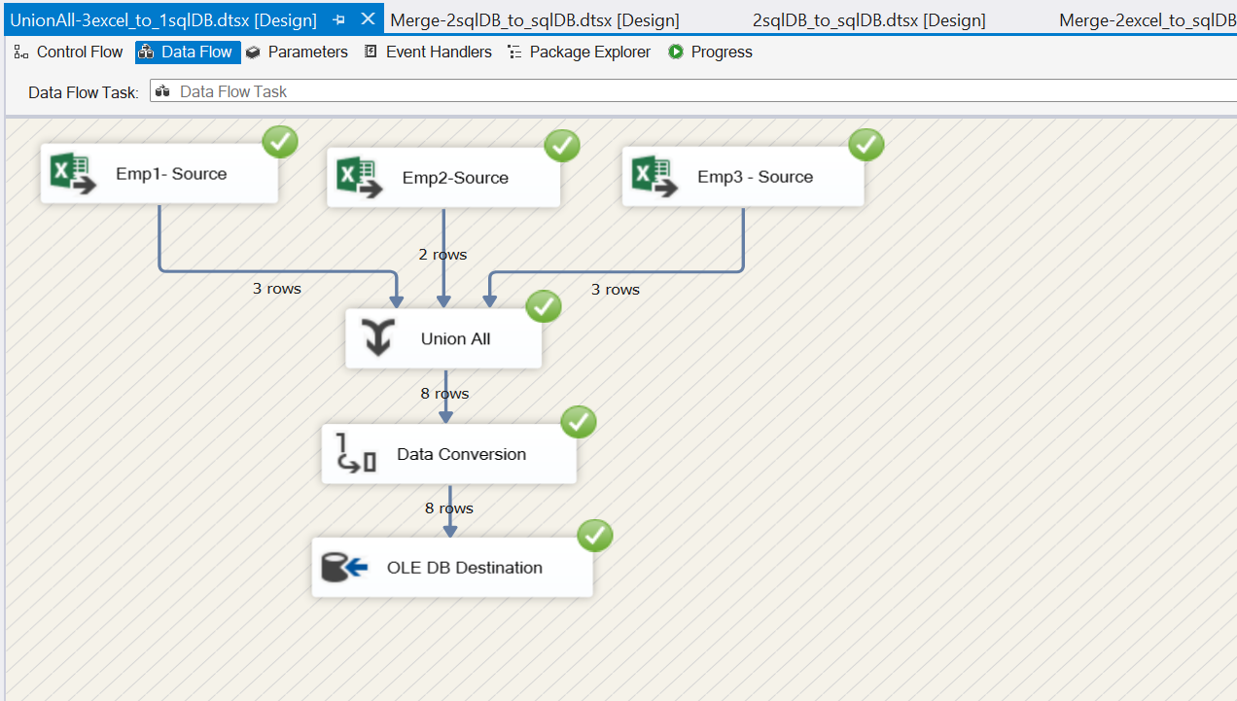

Employee source 1:

Employee source 2:

Employee source 3:

Union All Transformation – Destination:

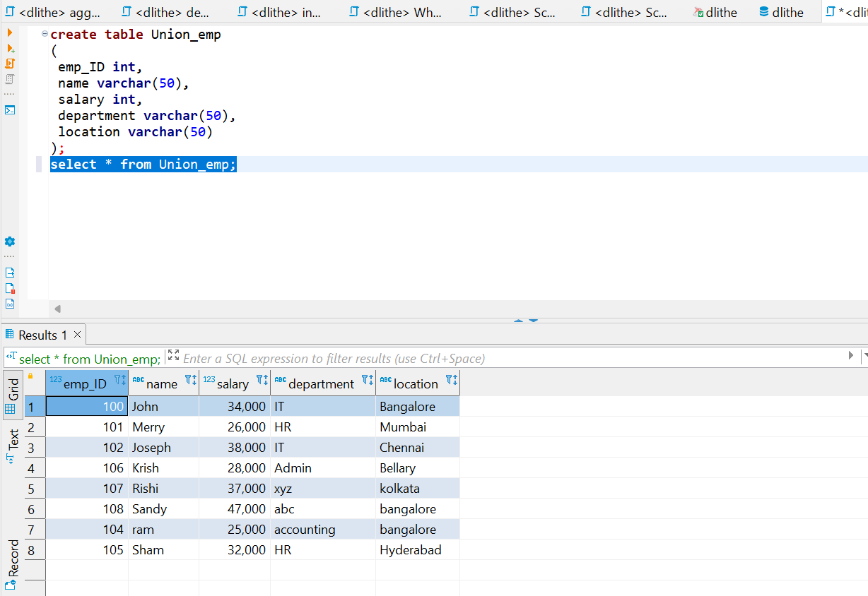

1. Source---Three Excel files Emp1, Flat, SQL Table  
   Destination--SQL Table-Employee table

Dataflow:

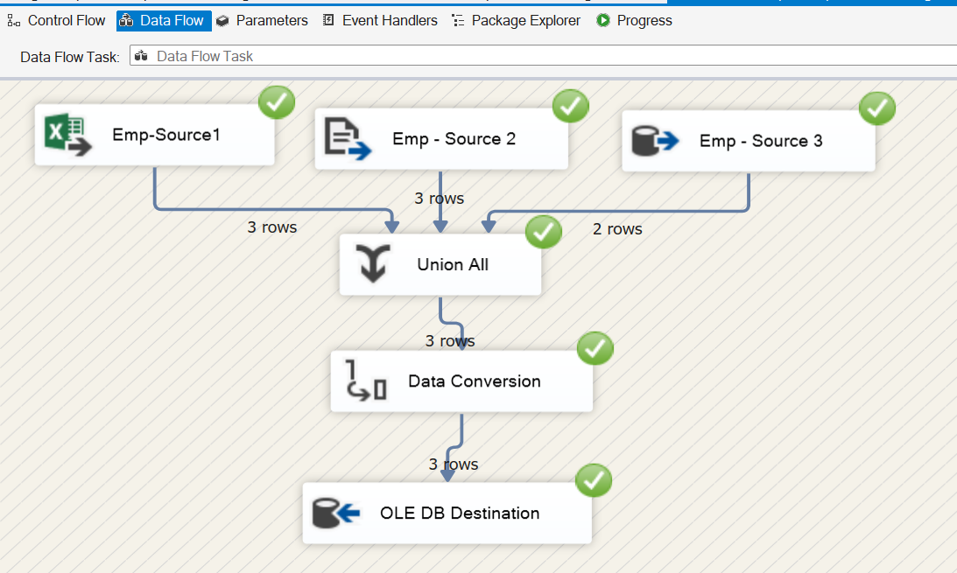

Source 1:

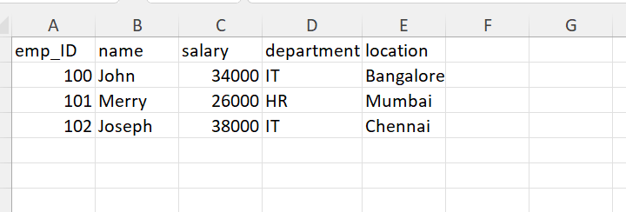

Source 2:

Source 3:

Destination:

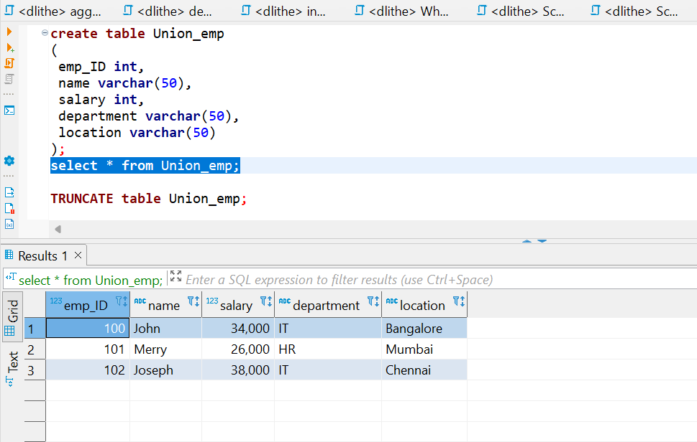

1. Source---Three SQL Table  
   Destination--Flat FIle

Dataflow :

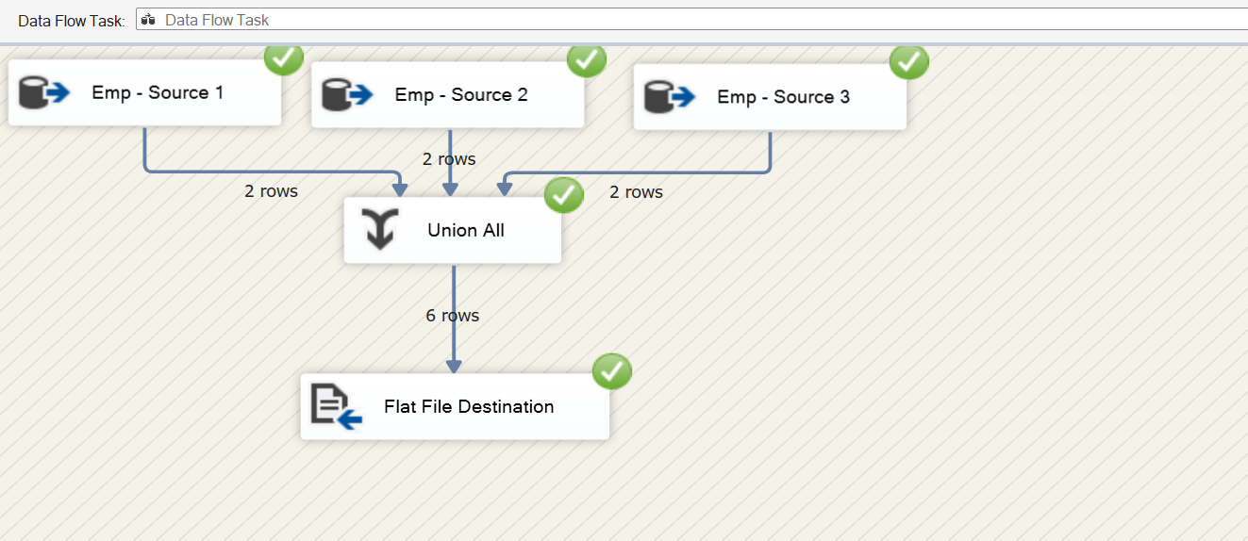

Source 1:

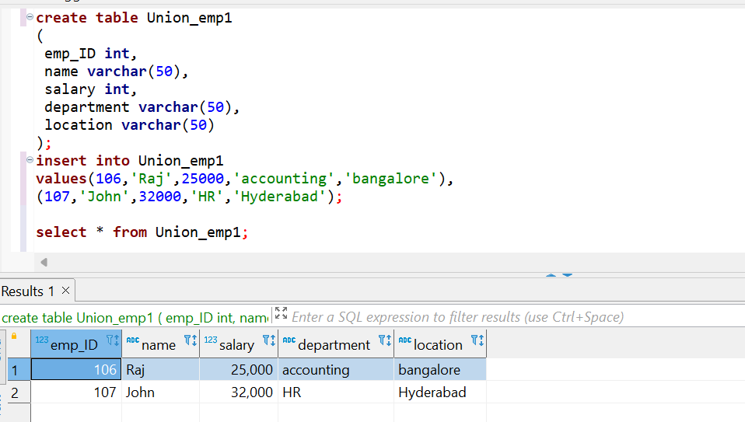

Source 2:

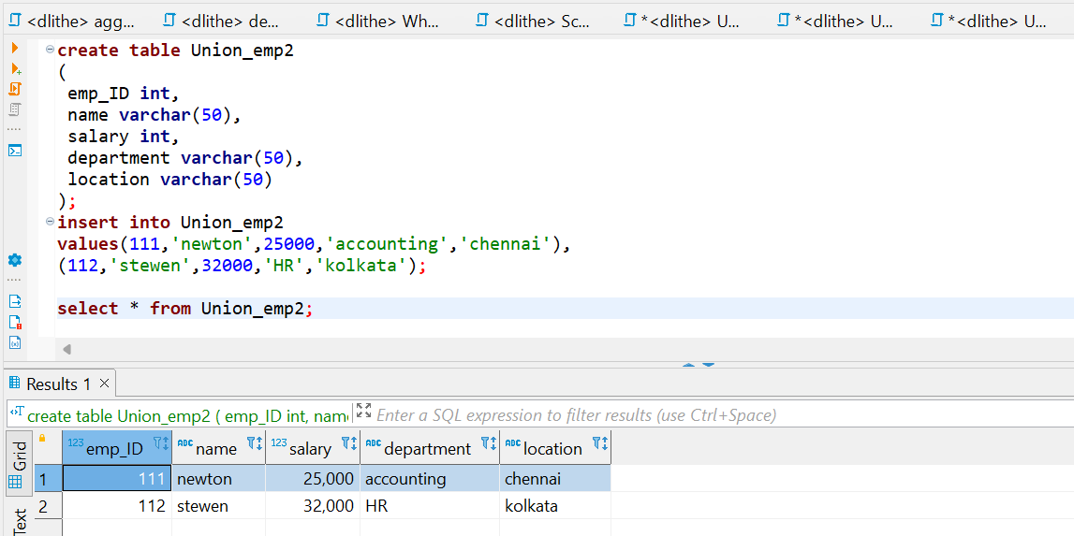

Source 3:

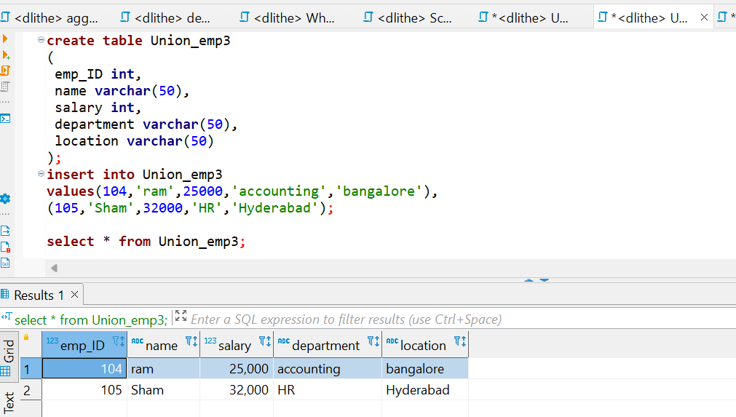

Destination:

